



Laboratory Rotation Report, May-July 2026

Context-dependent relationships between transcription factor contribution signals and gene expression during B-cell to macrophage transdifferentiation

Eirini DΙΜΑ,
BSc, MSc candidate in International MSc in Molecular Biomedicine

Supervisor: Dr. Christoforos Nikolaou, Researcher
Location: Computational Genomics Group - Institute for Bioinnovation (IBI), Biomedical Sciences Research Center "Alexander Fleming"
Duration: 01/05/2026 - 31/07/2026
Table of Contents
1. INTRODUCTION 2
2. METHODS 4
2.1 Dataset preparation and restructuring 4
2.2 Selection of positive contribution associations 5
2.3 Expression direction among positive contribution events 5
2.4 Correlation between positive contribution strength and gene expression intensity 6
2.5 Upstream and downstream TF binding analysis 6
2.6 TF-level proximal versus distal analysis 7
2.7 Gene-level proximal versus distal analysis 7
2.8 TF co-occurrence analysis 7
2.9 Statistical analysis 8
3. RESULTS 8
3.1 Positive contribution scores show increased absolute impact and variation 8
3.2 Positive contribution events show mixed expression-direction associations across timepoints 9
3.3 Positive contribution strength shows weak global but timepoint-specific TF-level associations with gene expression intensity 11
3.4 Positive contribution strength differs between upstream and downstream binding events across timepoints 14
3.5 TF-level proximal and distal tendencies are not strongly associated with gene expression differences 16
3.6 Gene-level proximal versus distal positioning shows only nominal expression differences 17
3.7 Co-occurring positive-contribution TFs are associated with distinct gene expression patterns 18
4. DISCUSSION 20
5. SUPPLEMENTARY DATA AND CODE AVAILABILITY 21
6. BIBLIOGRAPHY 22

INTRODUCTION
Gene expression regulation is fundamental for the establishment and maintenance of cellular identity. Although all cells of an organism contain essentially the same genomic information, different cell types acquire distinct morphologies, functions, and molecular programs through the selective activation and repression of specific genes. This process is controlled by a complex regulatory network involving transcription factors (TFs), cis-regulatory elements, chromatin accessibility, three-dimensional genome organization, and the interaction between enhancers and promoters[1], [2].
Within this regulatory network, TFs play a central role by recognizing specific DNA sequence motifs and influencing the expression of nearby or distal target genes [3]. However, the regulatory effect of a TF binding event is not determined only by the identity of the TF itself. Instead, TF function is highly context-dependent and may be influenced by the chromatin environment, the presence of cooperating or competing TFs, the distance from the transcription start site (TSS), and the exact position of the binding site relative to the promoter [4], [5]. Therefore, the same TF can be associated with different transcriptional outcomes depending on the regulatory context in which it binds.
One important framework for understanding this context-dependent regulation is enhancer grammar. Enhancers are key cis-regulatory elements that integrate TF binding information to establish cell-type-specific gene expression patterns. Enhancer grammar refers to the regulatory logic by which the identity, number, spacing, orientation, relative position and combinatorial organization of TF binding sites influence transcriptional output [6]. This concept is particularly relevant during cell fate transitions, where transcriptional programs must be dynamically reorganized over time.
The position of a TF binding site relative to the TSS has emerged as an important determinant of regulatory outcome. Recent studies have shown that several TFs, including NRF1, NFY and Sp1, can be associated with activation or repression depending on where they bind around the TSS. Upstream binding is often linked to transcriptional activation, whereas binding at or downstream of the TSS may interfere with transcription initiation or alter TSS selection. These findings highlight spatial positioning as an important layer of transcriptional regulation [7].
Beyond the position of individual binding sites, TF activity can also depend on the presence of other TFs within the same regulatory context. Regulatory elements often contain multiple TF motifs, and their output may reflect the combined effect of different factors rather than isolated binding events [8], [9]. Such context-dependent behavior is also consistent with studies of dual-function TFs, such as ZNF143, which can activate or repress different targets depending on binding position and regulatory context [10]. Together, these findings emphasize that TF activity should be interpreted within its genomic and molecular enviroment, rather than as a fixed activator or repressor function.
Τo study these regulatory principles in a dynamic biological system, this project uses the BLaER transdifferentiation model (Figure 1). Transdifferentiation refers to the direct conversion of one differentiated cell type into another without passing through a pluripotent intermediate state. BLaER cells are derived from a human B-cell leukemia line and can be induced to convert from a B-cell-like state toward a macrophage-like identity through β-estradiol-induced activation of the myeloid transcription factor C/EBPα [11]. This system provides a useful model for studying gene regulatory changes during cell fate conversion, as the transition occurs in a synchronized and time-resolved manner. In this project, the process is examined across three major timepoints: day 0, day 1 and day 7 of transdifferentiation, allowing regulatory changes to be followed from the initial B-cell-like state to the macrophage-like endpoint.
The analysis performed in this report is based on the integration of chromatin accessibility, predicted TF binding and gene expression information. ATAC-seq identifies open chromatin regions, which can represent potential regulatory elements and candidate TF binding sites, while RNA-seq captures gene expression at matched timepoints [12], Combining these data types makes it possible to explore whether predicted TF binding events are associated with the expression state of nearby genes during transdifferentiation.
A central computational component of this analysis is ChromBPNet, a deep learning model trained on ATAC-seq data to predict chromatin accessibility profiles directly from DNA sequence [13]. ChromBPNet-derived contribution scores estimate how strongly specific sequence features, including motif instances, contribute to the predicted accessibility signal. Positive contribution scores indicate features that support predicted chromatin accessibility, whereas negative contribution scores indicate features that contribute negatively to the predicted accessibility profile. Importantly, these scores describe contribution to predicted accessibility and should not be directly interpreted as transcriptional activation or repression.
The dataset used in this project links predicted TF binding sites to nearby genes and provides ChromBPNet-derived contribution scores together with gene expression z-scores across day 0, day 1 and day 7 of B-cell to macrophage transdifferentiation. Based on this framework, the aim of this report is to explore how TF contribution signals relate to gene expression during transdifferentiation. Rather than assuming that TFs act as fixed activators or repressors, this analysis examines how contribution score strength, genomic position relative to the TSS, distance from the associated gene and TF co-occurrence are associated with different expression outcomes.
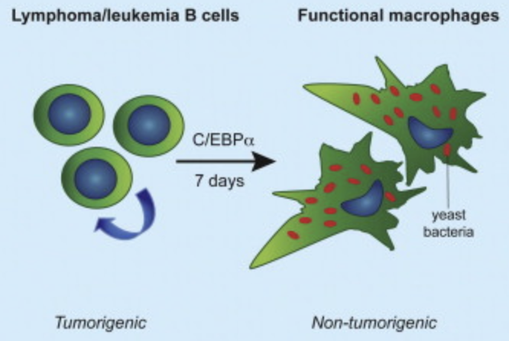
Figure 1. BLaER transdifferentiation model.
C/EBPα activation drives the conversion of leukemia B cells into macrophage-like cells within 7 days, providing a model to study gene regulatory changes during cell fate conversion (Adapted from Rapino et al., 2013)

METHODS

2.1 Dataset preparation and restructuring
All analyses were performed in R using a TF-gene centered dataset derived from ChromBPNet-based predictions during B-cell to macrophage transdifferentiation (file name: TF_gene_centric_with_zscores). Each row corresponded to a predicted TF-gene association and included motif information, distance from the transcription start site, ChromBPNet-derived contribution scores, and gene expression measurements across three timepoints (day 0, day 1 and day 7). The main columns used in the analysis were TFName, corresponding to the predicted transcription factor, gene_name, corresponding to the associated nearby gene, dist_to_TSS, representing the distance of the predicted TF binding site from the transcription start site, mean_contrib_day_0, mean_contrib_day_1 and mean_contrib_day_7, representing the mean ChromBPNet-derived contribution score at each timepoint, and z_expr_0d, z_expr_1d and z_expr_7d, representing standardized gene expression values at each timepoint. Gene expression z-scores indicate whether a gene’s expression at a given timepoint is above or below its mean expression across the time course. Additional information, including JASPAR motif identifiers, motif p-values, raw expression values, log2-fold-change values, gene strand, and TSS coordinates, was also available in the original dataset. To directly compare TF contribution scores with gene expression at matching stages of transdifferentiation, the dataset was converted from wide to long format. In the long-format table, each row represented one TF-gene association at a specific timepoint, with the corresponding contribution score matched to the gene expression z-score. This unified table was used as the input for downstream analyses.

2.2 Selection of positive contribution associations
To compare the relative magnitude of positive and negative ChromBPNet contribution signals, contribution scores were first converted to long format across the three timepoints. Non-zero contribution scores were classified according to their sign, and negative contribution scores were converted to absolute values to allow comparison of contribution magnitude independently of direction. For each contribution direction, summary statistics were calculated, including the number of observations, mean, median, interquartile range, upper quantiles, and maximum magnitude. The distributions of positive and absolute negative contribution scores were visualized using boxplots. Based on this magnitude comparison, downstream analyses focused on positive contribution scores, which represented the dominant contribution signal in the dataset.

2.3 Expression direction among positive contribution events
To examine whether positive TF contribution scores were associated with positive or negative gene expression, the dataset was converted to long format by matching each timepoint-specific contribution score with the corresponding gene expression z-score. Only positive contribution scores were retained for this analysis. For each positive contribution event, gene expression was classified according to the sign of the matched z-score. Expression values with z-scores greater than zero were classified as positive expression, whereas values below zero were classified as negative expression. Expression-direction counts and fractions were calculated for each TF both overall and separately per timepoint. The main statistical analysis was then performed separately for each timepoint. For each timepoint, a timepoint-specific global positive-expression fraction was calculated using all positive contribution events at that timepoint. Each TF-timepoint case was tested against the corresponding timepoint-specific background using a two-sided binomial test. P-values were adjusted for multiple testing using the Benjamini-Hochberg method separately within each timepoint. TF-timepoint cases were classified as positive-expression enriched or negative-expression enriched depending on whether their positive-expression fraction was higher or lower than the timepoint-specific global background. TF-timepoint cases were considered statistically significant if they had at least 50 positive contribution events and a Benjamini-Hochberg adjusted p-value below 0.05.

2.4 Correlation between positive contribution strength and gene expression intensity
To examine whether positive contribution score magnitude was associated with gene expression intensity, positive contribution scores were correlated with the corresponding gene expression z-scores at the same timepoint. Only positive contribution events with non-missing contribution and expression values were retained, and events with zero expression scores were excluded. Each event was classified as positive-expression or negative-expression according to the sign of the matched expression z-score. Correlation analyses were performed separately for each timepoint and expression-direction group. For each timepoint-expression group, both Pearson and Spearman correlation coefficients and corresponding p-values were calculated between positive contribution score magnitude and matched gene expression z-scores. The same analysis was then repeated at the TF level, separately for each TF, timepoint and expression-direction group. TF-level groups were included only if they contained at least three observations and showed non-zero variation in both contribution score and expression score. P-values from the TF-level correlation analysis were adjusted using the Benjamini-Hochberg method separately within each timepoint and expression-direction group. Significant TF-timepoint correlation hits were defined as cases with at least 50 observations, adjusted Spearman p-value < 0.05, and absolute Spearman correlation coefficient ≥ 0.2.

2.5 Upstream and downstream TF binding analysis
To investigate whether positive contribution scores differed according to the position of predicted TF binding events relative to the transcription start site (TSS), associations were classified as upstream or downstream based on their dist_to_TSS value. Negative dist_to_TSS values were classified as upstream, whereas positive values were classified as downstream. Associations located exactly at the TSS were excluded. The dataset was converted to long format across the three timepoints, and only positive contribution scores were retained. For each TF, timepoint, and TSS-side category, the number of positive contribution events, mean contribution score, median contribution score, and standard deviation were calculated. To compare upstream and downstream contribution score distributions, Wilcoxon rank-sum tests were performed separately for each TF and timepoint, provided that both upstream and downstream groups contained at least three observations. P-values were adjusted within each timepoint using the Benjamini-Hochberg method. Significant cases were classified according to whether the median positive contribution score was higher upstream or downstream of the TSS.

2.6 TF-level proximal versus distal analysis
To examine whether TFs with different positional tendencies were associated with distinct gene expression patterns, a proximal versus distal analysis was performed using only positive contribution events. First, the absolute distance from the TSS was calculated for each TF-gene association using dist_to_TSS. The dataset was then converted to long format across the three timepoints, and only positive contribution scores were retained. For each TF-gene pair, the mean and median absolute distance from the TSS were calculated across positive contribution events. These gene-level distance values were then summarized per TF by calculating the mean of the gene-level mean absolute TSS distances. This generated a TF-level positional measure representing whether each TF tended to be associated with genes through more proximal or more distal binding events. TFs were classified as proximal or distal using a cutoff of 10,000 bp. TFs with a mean gene-level absolute TSS distance ≤10,000 bp were classified as proximal TFs, whereas TFs with values greater than 10,000 bp were classified as distal TFs. The distribution of TF-level mean TSS distances was visualized using histograms. To compare gene expression patterns between proximal and distal TFs, expression z-scores were collapsed at the TF-gene pair level and then converted to long format across day 0, day 1 and day 7. For each timepoint, expression z-scores associated with proximal and distal TFs were summarized and compared using Wilcoxon rank-sum tests. p-values were adjusted for multiple testing using the Benjamini-Hochberg method.

2.7 Gene-level proximal versus distal analysis
To investigate proximal and distal regulatory associations at the TF-gene pair level, the analysis was repeated using only positive contribution events. The dataset was first converted to long format and only non-missing positive contribution scores were retained. Each positive contribution event was classified according to its distance from the TSS. Events located within +/-2,000 bp from the TSS were classified as proximal, whereas events located farther than +/-2,000 bp were classified as distal. Positive contribution events were then collapsed at the TF-gene pair level to summarize whether each pair contained proximal, distal, or both types of positive contribution events. Based on this classification, TF-gene pairs were assigned to one of three categories: proximal_only, distal_only, or both. Gene expression z-scores were then converted to long format so that each TF-gene pair was represented separately at day 0, day 1 and day 7. For each TF and timepoint, gene expression was compared between proximal_only and distal_only TF-gene pairs using Wilcoxon rank-sum tests. Comparisons were performed only when both groups contained at least three TF-gene pairs. P-values were adjusted for multiple testing using the Benjamini-Hochberg method separately for each timepoint.

2.8 TF co-occurrence analysis
To investigate whether pairs of TFs with positive contribution scores were associated with distinct gene expression patterns, a TF co-occurrence analysis was performed. The dataset was first converted to long format by matching each timepoint-specific contribution score with the corresponding gene expression z-score, and only positive contribution events were retained. A TF was considered associated with a gene if it had at least one positive contribution event for that gene. Unique TF-gene associations were extracted, and TFs were ranked according to the number of unique genes with which they were associated. The top 30 TFs with the highest number of positive-contribution gene associations were selected, and all unique pairwise combinations among these TFs were generated. For each TF pair, genes were classified into three categories: TF1_only, TF2_only, and Both_TFs, representing genes associated only with the first TF, only with the second TF, or with both TFs, respectively. Gene expression z-scores for day 0, day 1 and day 7 were then added to each gene category. For each TF pair, gene category and timepoint, the number of genes, mean expression, median expression and standard deviation were calculated. To compare expression patterns between categories, pairwise Wilcoxon rank-sum tests were performed separately for each TF pair and timepoint. Only TF pair-timepoint combinations with at least 30 genes in all three categories were included. Three comparisons were performed: Both_TFs versus TF1_only, Both_TFs versus TF2_only,and TF1_only versus TF2_only. P-values were adjusted using the Benjamini-Hochberg method within each timepoint and comparison type. Significant TF pair results were further classified according to the direction of the expression difference between categories.

2.9 Statistical analysis
All statistical analyses were performed in R. For comparisons between two groups, Wilcoxon rank-sum tests were used. This test was applied in the upstream versus downstream analysis, the proximal versus distal TF classification analysis, and the TF pair gene expression comparisons. For the analysis of expression direction among positive contribution events, two-sided binomial tests were used to compare the positive-expression fraction of each TF against the timepoint-specific global positive-expression background of the dataset. Correlation analysis between positive contribution scores and gene expression z-scores were performed using both Pearson and Spearman correlation coefficients. Spearman correlation was used to define significant TF-level correlation hits, as it is less sensitive to non-linear relationships and outliers. Multiple testing correction was performed using the Benjamini-Hochberg method. Adjusted p-values below 0.05 were considered statistically significant. Additional filtering thresholds were applied where appropriate, including a minimum of 50 observations for candidate transcription factors in the binomial and correlation analyses, at least 3 observations per group for Wilcoxon testing in the upstream/downstream analysis, and at least 30 genes in each gene category for TF pair comparisons.

RESULTS

3.1 Positive contribution scores show increased absolute impact and variation
Before focusing on downstream analyses, we compared the magnitude of positive contribution scores with that of negative contribution scores. Since negative contribution scores have the opposite sign, they were converted to absolute values to compare signal intensity independently of direction. Positive contribution scores showed substantially higher magnitudes than absolute negative contribution scores. Although negative contribution observations were slightly more frequent, their magnitude was consistently lower. Specifically, positive contribution scores had a mean magnitude of 0.0154 and a median magnitude of 0.0124, whereas absolute negative contribution scores had a mean magnitude of 0.0040 and a median magnitude of 0.0037. The same pattern was observed in the upper quantiles, with the 95th percentile reaching 0.0430 for positive contributions compared with 0.0093 for absolute negative contributions (Table 1). This difference was also evident in the boxplot, where positive contribution scores showed a higher median and broader distribution than absolute negative contribution scores (Figure 2). Based on this difference in signal strength, all downstream analyses were restricted to positive contribution scores.

Contribution Direction | Observations | Mean magnitude | Median Magnitude | Q95 magnitude | Max magnitude
Negative | 266768 | 0.00396 | 0.00367 | 0.00934 | 0.03881
Positive | 241150 | 0.01539 | 0.01236 | 0.04297 | 0.16882
Table 1. Magnitude summary of positive and negative contribution scores.
Positive and negative contribution scores were compared based on their absolute magnitude. Positive contribution scores showed higher mean, median and 95th percentile magnitude than absolute negative contribution scores. The complete event-level dataset used for this comparison is available through the provided link.

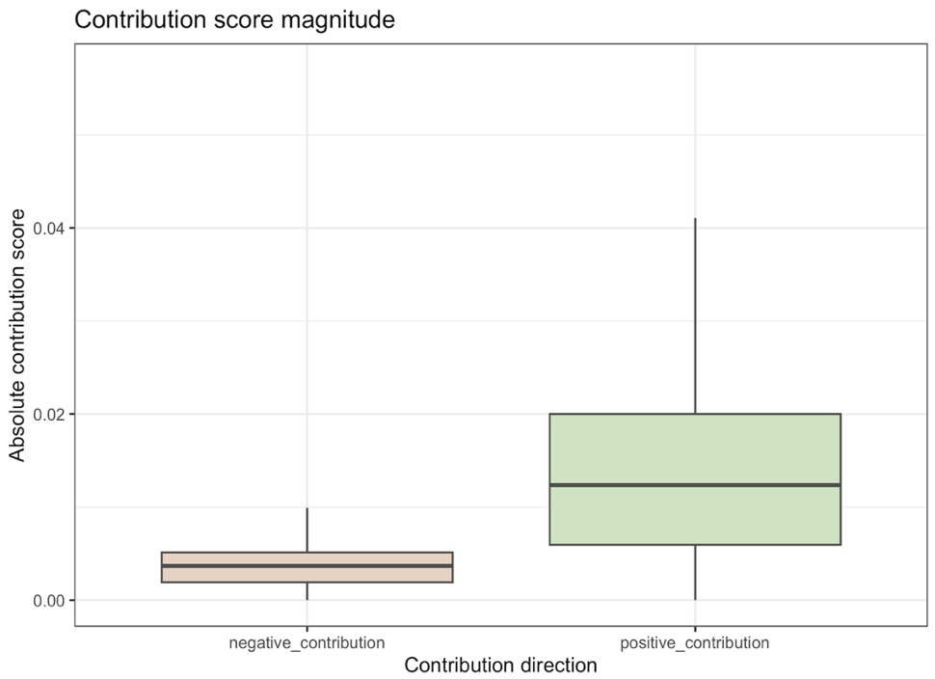

Figure 2. Magnitude comparison of positive and negative contribution scores.
Boxplot comparing positive contribution score magnitudes with absolute negative contribution score magnitudes. Positive contribution scores showed higher median magnitude and a broader distribution, supporting their selection for downstream analyses.

3.2 Positive contribution events show mixed expression-direction associations across timepoints
After selecting positive contribution scores, we examined whether these events were preferentially associated with positive or negative gene expression. For each TF binding site-gene association and timepoint, the matched gene expression z-score was classified as positive or negative. Expression-direction counts were then calculated separately for day 0, day 1 and day 7. Across all three timepoints, positive contribution events were associated with both positive and negative gene expression (Figure 3). The boxplots additionally display the distribution of positive contribution scores within each group, while the labels above the boxes indicate the corresponding event counts. At day 0, 41527 positive contribution events were associated with positive expression and 39075 with negative expression. In contrast, day 1 showed 38720 positive-expression events and 41909 negative-expression events, while day 7 showed 39206 positive-expression events and 40713 negative-expression events. This indicates that positive contribution events were not exclusively associated with increased gene expression. Instead, the expression-direction background varied modestly across the transdifferentiation time course, with a slight positive-expression enrichment at day 0 and slightly more negative-expression events at day 1 and day 7. To test whether individual TFs showed expression-direction bias beyond the corresponding timepoint-specific background, each TF-timepoint case was tested using a two-sided binomial test. This identified 23 significant TF-timepoint cases after Benjamini-Hochberg correction, all of which occurred at day 0. Among these significant cases, 21 were enriched for positive-expression associations, whereas 2 were enriched for negative-expression associations. The top 10 significant TF-timepoint cases ranked by adjusted p-value are shown in Table 2. Overall, these results show that positive contribution scores should not be interpreted as direct indicators of transcriptional activation. Although several TFs showed significant expression-direction bias at day 0, positive contribution events were globally associated with both positive and negative gene expression across the time course. This suggests that the relationship between ChromBPNet-derived contribution signals and gene expression depends on TF identity, timepoint and regulatory context.
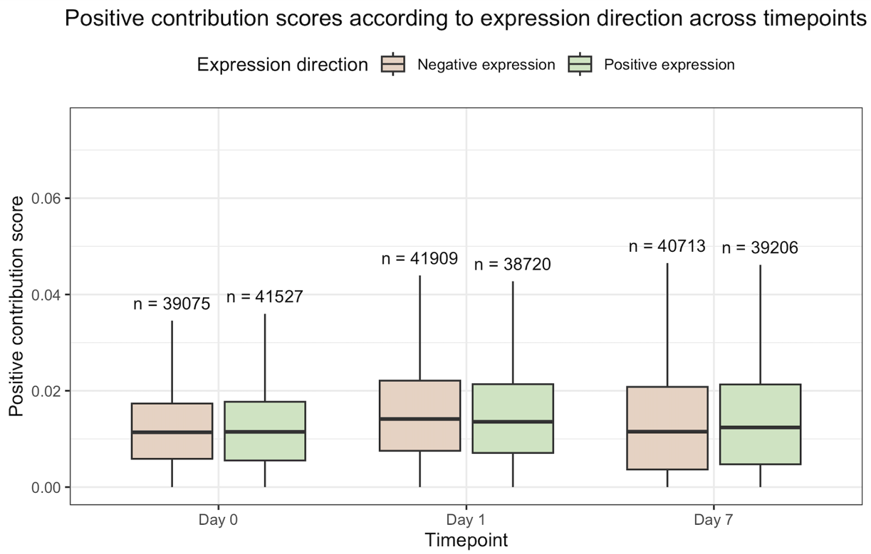

Figure 3. Expression direction among positive contribution events across timepoints.
Positive ChromBPNet contribution events were classified as associated with positive or negative gene expression according to the sign of the matched expression z-score at day 0, day 1 and day 7 of B-cell-to-macrophage transdifferentiation. The number of events in each expression-direction group is indicated above the corresponding boxplot and was used to define the timepoint-specific expression-direction background. Boxplots additionally show the distribution of positive contribution scores within each group. The complete event-level dataset used to generate the boxplots is available through the provided link.

TF | Timepoint | Total events | Positive-expression fraction | Δ from background | Bias | Raw p-value | BH-adj. p-value
Dlx3 | day 0 | 310 | 0.639 | 0.124 | Positive-expression enriched | 1.81 × 10⁻⁵ | 0.010
HESX1 | day 0 | 315 | 0.635 | 0.120 | Positive-expression enriched | 2.54 × 10⁻⁵ | 0.010
TBP | day 0 | 330 | 0.624 | 0.109 | Positive-expression enriched | 9.25 × 10⁻⁵ | 0.015
PLAGL2 | day 0 | 286 | 0.399 | -0.116 | Negative-expression enriched | 9.72 × 10⁻⁵ | 0.015
ISX | day 0 | 300 | 0.627 | 0.111 | Positive-expression enriched | 1.30 × 10⁻⁴ | 0.015
Nobox | day 0 | 300 | 0.627 | 0.111 | Positive-expression enriched | 1.30 × 10⁻⁴ | 0.015
UNCX | day 0 | 206 | 0.660 | 0.145 | Positive-expression enriched | 2.45 × 10⁻⁴ | 0.021
TLX2 | day 0 | 330 | 0.615 | 0.100 | Positive-expression enriched | 2.64 × 10⁻⁴ | 0.021
LBX2 | day 0 | 330 | 0.615 | 0.100 | Positive-expression enriched | 2.64 × 10⁻⁴ | 0.021
EN1 | day 0 | 447 | 0.595 | 0.080 | Positive-expression enriched | 3.21 × 10⁻⁴ | 0.023
Table 2. Top significant TF-timepoint expression-direction biases among positive contribution events.
Top 10 significant TF-timepoint cases ranked by Benjamini-Hochberg adjusted binomial p-value. Each TF-timepoint case was tested against the global positive-expression fraction of the corresponding timepoint. All displayed hits had at least 50 positive contribution events and remained significant after multiple-testing correction. The complete binomial-test results for all TF-timepoint cases are available through the provided link.

3.3 Positive contribution strength shows weak global but timepoint-specific TF-level associations with gene expression intensity
After examining expression direction among positive contribution events, we next asked whether positive contribution score magnitude was associated with gene expression intensity. Positive contribution scores were correlated with matched gene expression z-scores separately for each timepoint and expression-direction group. At the global level, correlations were weak across all timepoints (Figure 4). Day 0 showed weak positive Spearman correlations for both negative-expression events and positive-expression events, with ρ = 0.085 and ρ = 0.039, respectively. At day 1, correlations were close to zero and slightly negative, while at day 7 they became more clearly negative, although still weak, with ρ = -0.143 for negative-expression events and ρ = -0.086 for positive-expression events. These results indicate that positive contribution score magnitude alone was not globally predictive of gene expression intensity. The analysis was then repeated separately for each TF, timepoint and expression-direction group. After applying the observation number, significance and effect-size thresholds, 37 significant TF-timepoint correlation hits were identified (Table 4). The complete set of 37 significant correlation cases is available through the provided link. Most hits were detected at day 7, suggesting that TF-specific contribution-expression relationships may become more apparent at the later stage of transdifferentiation. In total, 34 of the 37 significant hits showed negative Spearman correlations, indicating that higher positive contribution scores were generally associated with lower gene expression z-scores within the corresponding expression-direction group. Within negative-expression events, this corresponded to stronger negative expression, whereas within positive-expression events it corresponded to weaker positive expression. Therefore, these results do not support a simple activation-like interpretation of positive contribution strength. Instead, they suggest that stronger accessibility-supporting contribution signals can be associated with reduced relative expression intensity in specific TF-timepoint contexts. This pattern may reflect the broader molecular context of TF binding, since individual binding events do not occur in isolation and the presence of additional co-bound factors may modulate the associated expression outcome. This possibility was further explored in the subsequent TF co-occurrence analysis. As an additional timecourse analysis, contribution-expression correlations were calculated for individual TF-gene pairs represented at day 0, day 1 and day 7. In total, 38,986 TF-gene pairs could be evaluated. The correlations were nearly evenly distributed between negative and positive patterns, with 20,072 negative and 18,914 positive correlations. The distribution across the four possible Spearman correlation coefficients is presented in Table 5, while the corresponding bar plot and complete TF-gene-level correlation dataset is provided through this link. Overall, these findings indicate that positive contribution strength is not uniformly associated with gene expression intensity, but instead shows heterogeneous TF-specific, timepoint-specific and TF-gene temporal relationships that likely depend on the broader regulatory context.
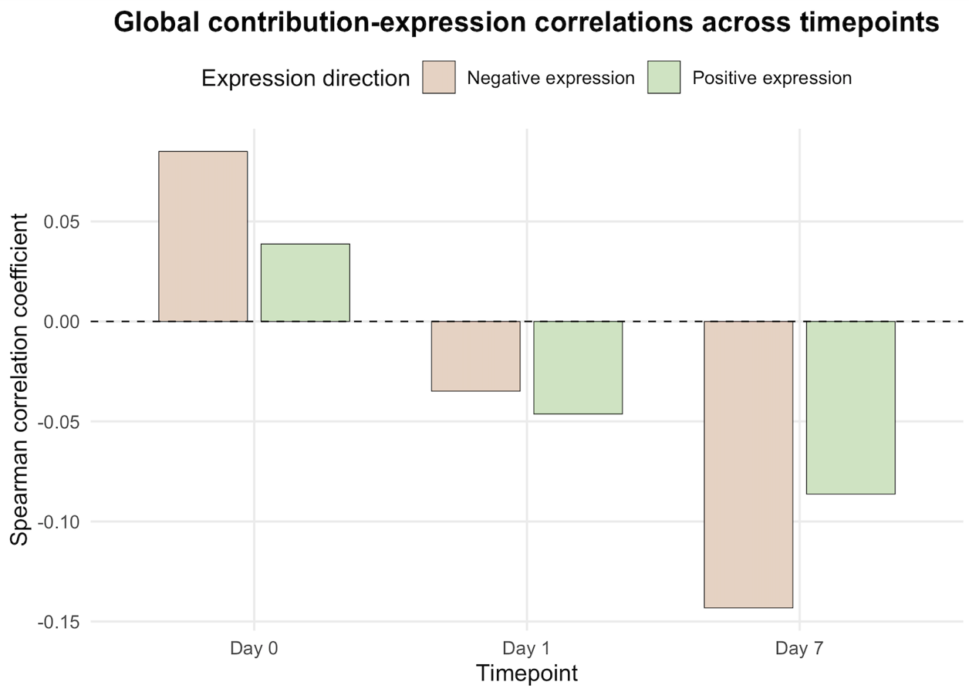
Figure 4. Global correlations between positive contribution score magnitude and gene expression intensity across timepoints.
Bar plot showing Spearman correlation coefficients between positive contribution scores and matched gene expression z-scores, calculated separately for positive-expression and negative-expression events at day 0, day 1 and day 7 of B-cell to macrophage transdifferentiation. Correlations were weak across all timepoints. Day 0 showed weak positive correlations, whereas day 1 and day 7 showed negative correlations, with the strongest negative global trend observed at day 7. The complete global correlation results, including Pearson and Spearman coefficients and corresponding p-values, are available through the provided link.

TF | Timepoint | Expression group | n observations | Pearson r | Spearman ρ | BH-adj. p-value
TFAP2A | day 7 | Negative expression | 327 | -0.203 | -0.253 | 0.000256
HOXB1 | day 7 | Negative expression | 83 | -0.423 | -0.470 | 0.000481
TFAP2E | day 7 | Negative expression | 280 | -0.208 | -0.240 | 0.00269
ZNF175 | day 7 | Positive expression | 119 | -0.336 | -0.356 | 0.00512
HOXA1 | day 0 | Negative expression | 80 | 0.215 | 0.420 | 0.00639
Ikzf3 | day 7 | Positive expression | 133 | -0.299 | -0.331 | 0.00663
ETV1 | day 7 | Positive expression | 156 | -0.297 | -0.304 | 0.00686
EBF3 | day 1 | Positive expression | 99 | -0.268 | -0.377 | 0.00801
ETV5::FOXO1 | day 7 | Negative expression | 76 | -0.329 | -0.415 | 0.00827
MEOX1 | day 7 | Negative expression | 60 | -0.327 | -0.464 | 0.00827
Table 4. Top significant TF-timepoint contribution-expression correlation hits.
Top 10 significant TF-timepoint-expression direction cases ranked by Benjamini-Hochberg adjusted Spearman p-value. Correlations were calculated between positive contribution score magnitude and matched gene expression z-scores separately for each timepoint and expression-direction group. Significant hits were defined as cases with at least 50 observations, adjusted Spearman p-value below 0.05, and absolute Spearman correlation coefficient ≥ 0.2. The complete TF-level correlation results for all tested TF-timepoint-expression-direction groups are available through the provided link.

Spearman correlation coefficient (ρ) | Number of TF-gene pairs
−1.0 | 7094
−0.5 | 12978
0.5 | 12141
1.0 | 6773
Table 5. Distribution of TF-gene contribution-expression correlations across the three timepoints.
Spearman correlation coefficients were calculated separately for each TF-gene pair using matched mean positive contribution scores and gene expression z-scores at day 0, day 1 and day 7. Because each correlation was based on three observations, the coefficients were restricted to four discrete values: -1, -0.5, 0.5 and 1.

3.4 Positive contribution strength differs between upstream and downstream binding events across timepoints
To investigate whether positive contribution score intensity was associated with the position of predicted TF binding events relative to the transcription start site, positive contribution events were classified as upstream or downstream based on the sign of dist_to_TSS. Across all timepoints, most positive contribution events were located downstream of the TSS, with 186,562 downstream events compared with 54,501 upstream events. Despite the higher number of downstream events, significant differences in contribution score magnitude were frequently observed between upstream and downstream events. Wilcoxon rank-sum tests were performed separately for each TF and timepoint, followed by Benjamini-Hochberg correction within each timepoint. In total, 165 significant TF-timepoint cases were identified. Among these, 157 cases showed higher median positive contribution scores upstream of the TSS, whereas only 8 cases showed higher median scores downstream. The strongest upstream-higher pattern was observed at day 7 (Table 6), which contained 119 significant upstream-higher cases. In contrast, downstream-higher cases were rare and were observed mainly at earlier timepoints (Figure 5). Overall, these results suggest that the position of predicted TF binding events relative to the TSS is associated with differences in ChromBPNet-derived contribution strength. Specifically, upstream events tended to show stronger positive contribution scores for many TFs, especially at the late stage of transdifferentiation. This supports the idea that spatial positioning relative to the TSS may represent an important layer of TF regulatory context.

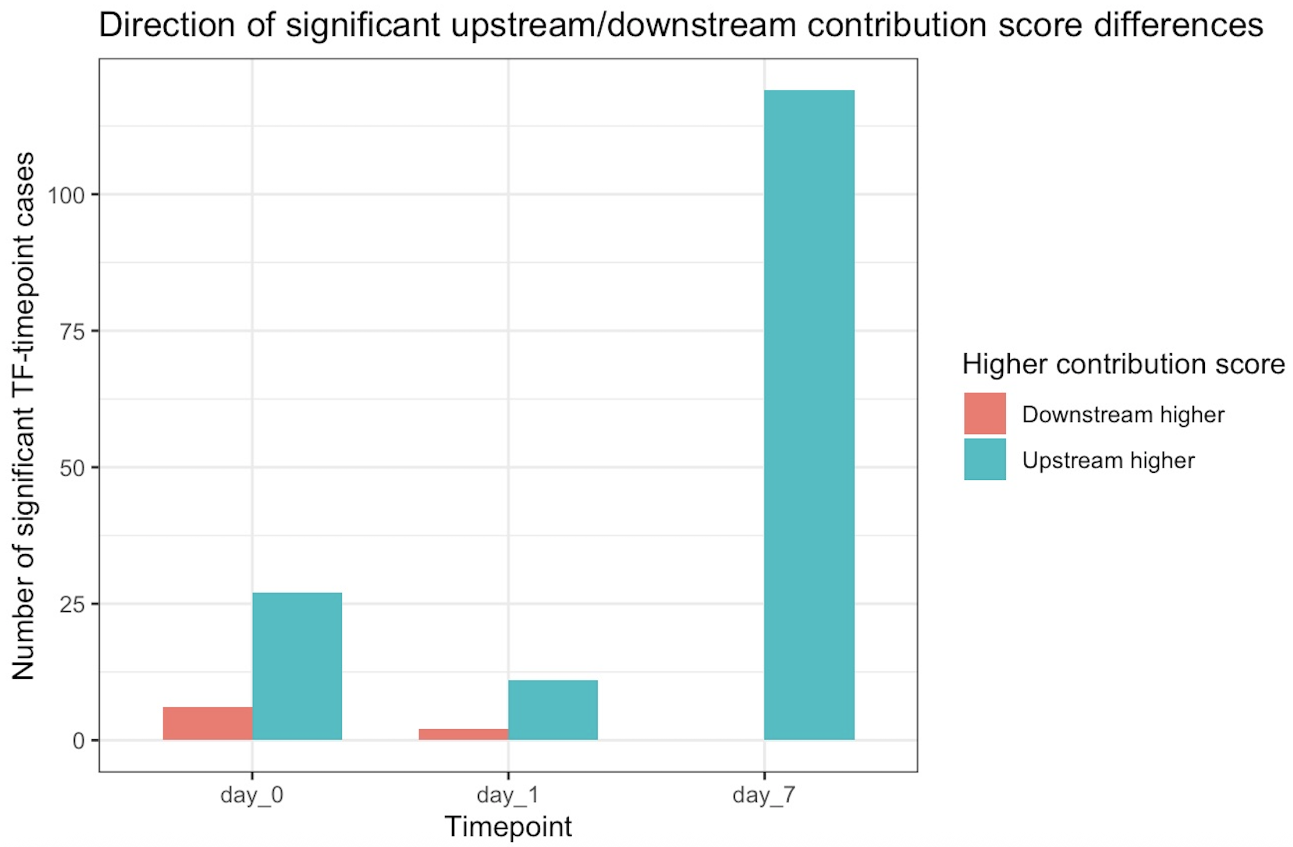
Figure 5. Direction of significant upstream/downstream contribution score differences across timepoints.
Bar plot showing the number of significant TF-timepoint cases in which positive contribution scores were higher upstream or downstream of the TSS after Wilcoxon rank-sum testing and Benjamini-Hochberg correction. The complete set of 165 significant TF-timepoint cases is available through the provided link.

TF | Timepoint | n upstream | n downstream | Median difference | BH-adjusted p-value | Higher contr. score
TFAP2B | day 7 | 199 | 491 | 0.0081 | 2.3 × 10⁻¹⁴ | Upstream
TFAP2A | day 7 | 181 | 433 | 0.0092 | 2.3 × 10⁻¹⁴ | Upstream
TFAP2C | day 7 | 153 | 386 | 0.0085 | 2.27 ×10⁻¹¹ | Upstream
TFAP2E | day 7 | 166 | 390 | 0.0082 | 2.49 ×10⁻¹¹ | Upstream
VEZF1 | day 7 | 304 | 522 | 0.0033 | 4.51 ×10⁻¹¹ | Upstream
TCFL5 | day 7 | 96 | 124 | 0.0078 | 6.79 × 10⁻⁹ | Upstream
Gmeb1 | day 7 | 126 | 136 | 0.0083 | 1.08 × 10⁻⁸ | Upstream
KLF2 | day 7 | 152 | 237 | 0.0048 | 1.3 × 10⁻⁶ | Upstream
NR2C2 | day 7 | 280 | 800 | 0.0040 | 1.3 × 10⁻⁶ | Upstream
HES1 | day 7 | 75 | 105 | 0.0081 | 1.3 × 10⁻⁶ | Upstream
Table 6. Top significant upstream/downstream positive contribution score differences.
Top 10 significant TF-timepoint cases ranked by Benjamini-Hochberg adjusted Wilcoxon p-value. The median difference was calculated as upstream minus downstream positive contribution score. Positive values indicate higher median contribution scores upstream of the TSS, whereas negative values indicate higher median contribution scores downstream. The complete Wilcoxon-test results for all tested TF-timepoint cases are available through the provided link.

3.5 TF-level proximal and distal tendencies are not strongly associated with gene expression differences
To examine whether TFs with more proximal or distal positional tendencies were associated with different gene expression patterns, TFs were classified according to their mean absolute distance from the TSS across positive contribution TF-gene associations. The distribution of TF-level mean TSS distances showed that most TFs were located beyond the proximal promoter region, with the majority of mean distances clustering between approximately 50 kb and 120 kb from the TSS (Figure 6). Using a 10 kb cutoff, TFs with a mean gene-level absolute TSS distance ≤10 kb were classified as proximal, whereas those with a mean distance >10 kb were classified as distal. Based on this definition, only 13 TFs were classified as proximal and 796 as distal. Using a 10 kb cutoff, only 13 TFs were classified as proximal, whereas 796 TFs were classified as distal. This indicates that, within the positive contribution dataset, most TFs showed a predominantly distal positional tendency rather than a proximal promoter-associated pattern. Gene expression z-scores associated with proximal and distal TF classes were then compared across the three timepoints. Although median expression differed slightly between the two groups at individual timepoints, none of these differences were statistically significant after Wilcoxon testing and Benjamini-Hochberg correction (Table 7). Therefore, TF-level proximal or distal tendency alone was not sufficient to explain major gene expression differences in this dataset. Overall, these results suggest that positive contribution signals are mainly associated with distal TF-gene associations, but this broad TF-level distance classification is not strongly predictive of gene expression.
Α
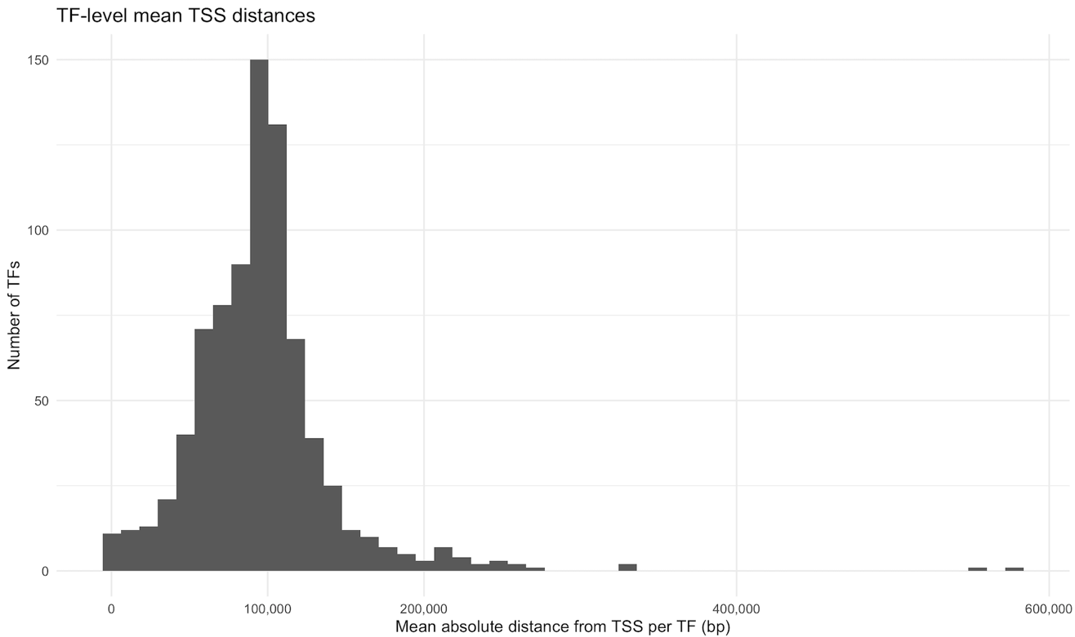

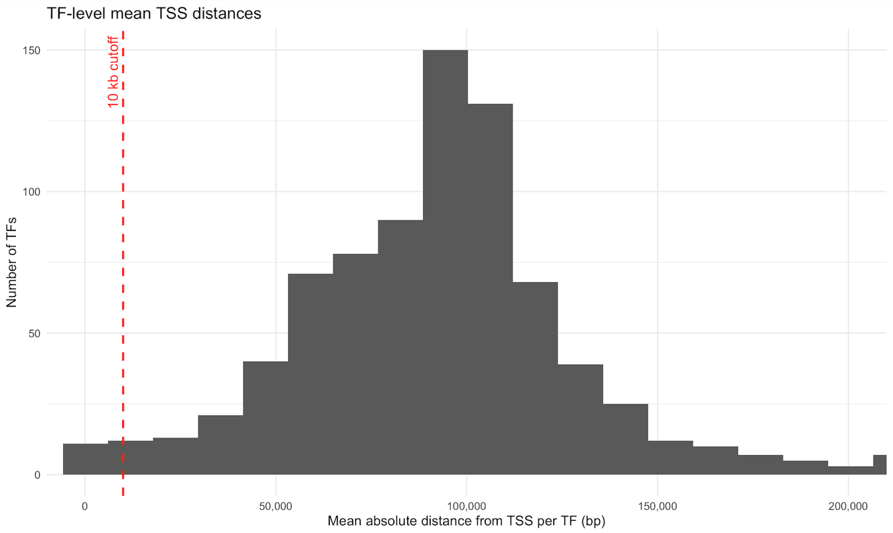
Β
Figure 6. Distribution of TF-level mean TSS distances.
(Α) Full histogram showing the distribution of mean absolute TSS distance per transcription factor, calculated from positive contribution TF-gene associations. (B) Zoomed view of the distribution up to 200 kb, showing the 10 kb cutoff used for proximal and distal TF classification (red dashed line). Most TFs displayed mean TSS distances greater than 10 kb, supporting their classification as distal TFs. The complete list of TF-level mean TSS distances and the corresponding proximal or distal classification is available through the provided link.

Timepoint | n proximal TF-gene pairs | n distal TF-gene pairs | Median proximal expr. | Median distal expr. | Median diff. | Wilcoxon p-value | BH-adj. p-value
day 0 | 46 | 51376 | -0.311 | 0.022 | -0.334 | 0.609 | 0.914
day 1 | 46 | 51376 | -0.000 | -0.036 | 0.035 | 0.932 | 0.932
day 7 | 46 | 51376 | 0.118 | -0.058 | 0.175 | 0.593 | 0.914
Table 7. Gene expression comparison between proximal and distal TF classes.
TFs were classified as proximal or distal using a 10 kb cutoff based on their TF-level mean absolute TSS distance. Gene expression z-scores associated with proximal and distal TF-gene pairs were compared separately at day 0, day 1 and day 7 using Wilcoxon rank-sum tests. No significant expression differences were detected after Benjamini-Hochberg correction.

3.6 Gene-level proximal versus distal positioning shows only nominal expression differences
To further examine whether the position of positive contribution events relative to the TSS was associated with gene expression, TF-gene pairs were classified as proximal_only, distal_only, or both. Most TF-gene pairs were classified as distal_only. Specifically, 43,069 TF-gene pairs contained only distal positive contribution events, whereas 8,296 contained only proximal positive contribution events and 57 contained both proximal and distal positive contribution events. This indicates that positive contribution TF-gene associations were predominantly located outside the proximal TSS region. Gene expression was then compared between proximal_only and distal_only TF-gene pairs separately for each TF and timepoint (Table 8). Several nominal differences were detected before multiple-testing correction, with 30 nominally significant comparisons at day 0, 35 at day 1 and 118 at day 7. However, no comparison remained statistically significant after Benjamini-Hochberg correction, with the lowest adjusted p-value being approximately 0.20. Although these results do not provide statistically robust evidence for gene-level expression differences between proximal-only and distal-only TF-gene pairs, the nominal results suggested a possible trend at day 7. In several of the top nominal comparisons, proximal-only TF-gene pairs showed lower median expression than distal-only pairs. However, these trends did not remain significant after correction for multiple testing. Overall, these findings suggest that, at the gene level, proximal versus distal positioning of positive contribution events alone was not sufficient to explain significant gene expression differences across the transdifferentiation time course.

TF | Timepoint | n proximal | n distal | Median proximal expr. | Median distal expr. | Median diff. | Raw p-value | BH-adj. p-value
FOXI1 | day 7 | 9 | 86 | -1.032 | 0.058 | -1.090 | 0.000931 | 0.200
JUNB | day 7 | 10 | 52 | -1.014 | 0.377 | -1.391 | 0.00103 | 0.200
CEBPD | day 7 | 6 | 53 | -1.048 | 0.252 | -1.300 | 0.00213 | 0.200
JUND | day 7 | 11 | 71 | -0.996 | 0.287 | -1.283 | 0.00231 | 0.200
Atf1 | day 7 | 15 | 55 | -0.922 | 0.504 | -1.426 | 0.00253 | 0.200
JDP2 | day 7 | 10 | 48 | -1.014 | -0.028 | -0.987 | 0.00358 | 0.200
IKZF1 | day 7 | 23 | 157 | -0.869 | 0.004 | -0.873 | 0.00421 | 0.200
RORC | day 7 | 14 | 67 | -0.950 | 0.063 | -1.013 | 0.00485 | 0.200
CREB1 | day 7 | 8 | 24 | -1.014 | 0.429 | -1.443 | 0.00500 | 0.200
FOSL1  ::JUND | day 7 | 15 | 106 | -0.971 | 0.217 | -1.188 | 0.00505 | 0.200
Table 8. Top nominal gene-level proximal versus distal expression differences.
Top 10 TF-timepoint comparisons ranked by Wilcoxon p-value. For each TF and timepoint, gene expression z-scores were compared between proximal_only and distal_only TF-gene pairs. P-values were adjusted using the Benjamini-Hochberg method. No comparison remained statistically significant after multiple-testing correction. The complete set of gene-level proximal versus distal expression comparisons is available through the provided link.

3.7 Co-occurring positive-contribution TFs are associated with distinct gene expression patterns
To examine whether TF co-occurrence was associated with gene expression differences, we focused on the top 30 TFs with the highest number of positive-contribution gene associations. All pairwise combinations among these TFs were generated, resulting in 435 TF pairs. For each pair, genes were divided into three groups: genes associated only with the first TF, genes associated only with the second TF, and genes associated with both TFs. TF pair-timepoint combinations were retained only when all three groups contained at least 30 genes, resulting in 265 valid comparisons per timepoint. Gene expression z-scores were then compared between the three groups using pairwise Wilcoxon rank-sum tests. After Benjamini-Hochberg correction, 49 TF pair-timepoint cases showed at least one significant expression difference between the gene groups, with the complete set available through the provided link. Most significant cases were observed at day 1, with 35 cases, while 14 were observed at day 7 and none at day 0. A bar plot summarizing the number of significant cases across timepoints is available through the provided link. These findings suggest that expression differences associated with TF co-occurrence were most evident during the early stage of transdifferentiation.The mean expression profiles of all 49 significant cases were visualized using a clustered heatmap (Figure 7), which revealed distinct TF-pair and timepoint-specific patterns. The top 10 cases ranked by minimum adjusted p-value are summarized in Table 9. In total, 46 significant comparisons involved genes associated with both TFs versus genes associated with only one TF, whereas 9 involved differences between the two single-TF gene groups. A descriptive analysis of the mean expression profiles further revealed a clear timepoint-dependent pattern (Table 10). At day 1, genes associated with both TFs had the lowest mean expression in 22 of the 35 significant cases, while in the remaining 13 cases their mean expression fell between the two single-TF groups. In contrast, at day 7, genes associated with both TFs had the highest mean expression in 12 of the 14 significant cases and an intermediate mean expression in the remaining 2 cases. These categories describe the relative ordering of the group means and do not imply that the genes associated with both TFs differed significantly from both single-TF groups in every case. Overall, genes associated with both TFs frequently displayed expression profiles distinct from genes associated with only one TF. Lower expression among genes associated with both TFs predominated at day 1, whereas higher expression predominated at day 7. This timepoint-dependent shift suggests that the expression context associated with TF co-occurrence changes during transdifferentiation rather than following a uniform pattern. However, these findings represent computational associations and do not demonstrate direct interactions between the TFs or causal effects on gene expression.
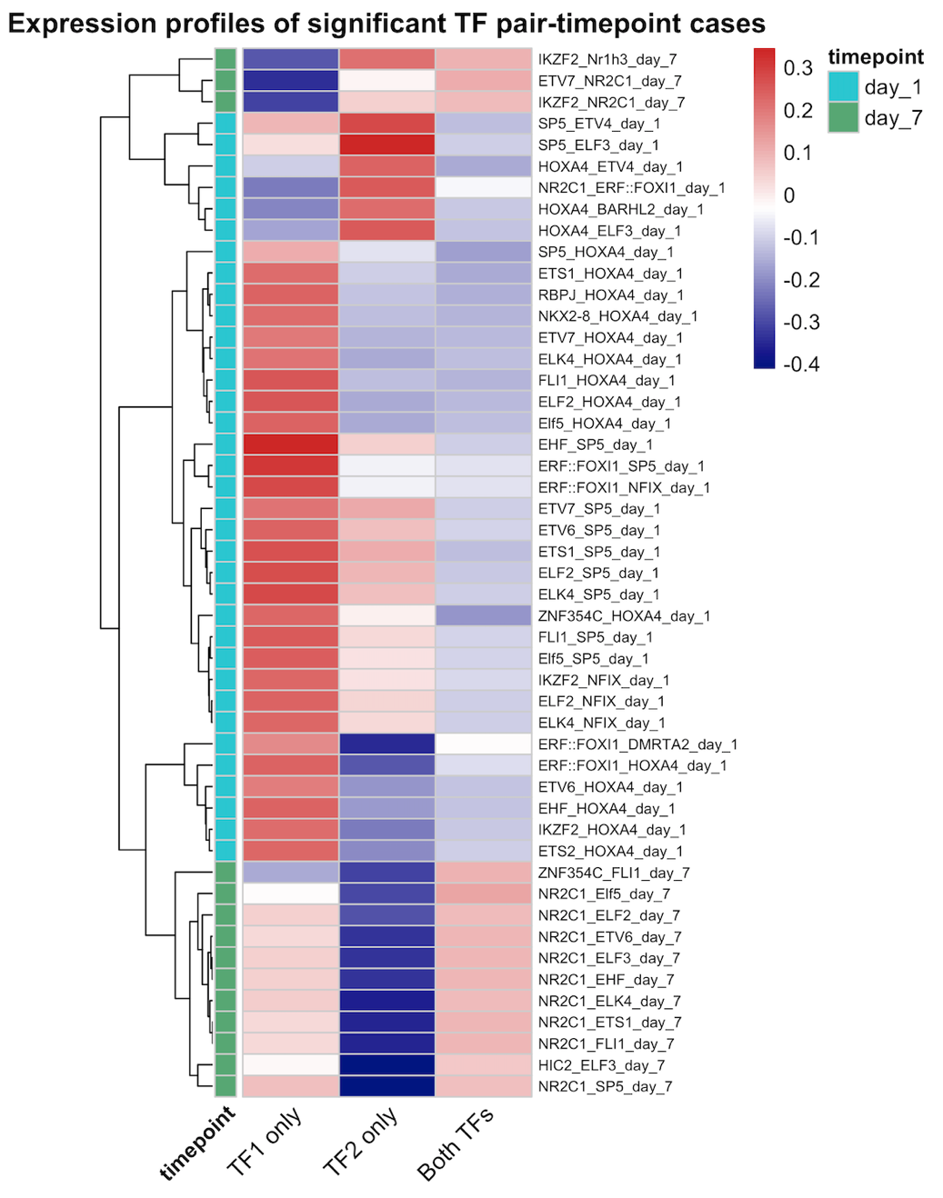

Figure 7. Clustered expression profiles of significant TF pair-timepoint cases
Heatmap showing the mean gene expression z-score for the TF1_only, TF2_only and Both_TFs gene categories in each significant TF pair-timepoint case. Rows represent individual TF pair-timepoint combinations and were clustered according to similarity in their three-category expression profiles. The annotation indicates the corresponding timepoint. (dataset used)

TF1 | TF2 | Timepoint | Significant comparison | No. of significant comparisons | Minimum BH-adjusted p-value
EHF | SP5 | day 1 | Both_TFs < TF1_only | 1 | 0.0140
ZNF354C | HOXA4 | day 1 | Both_TFs < TF1_only | 1 | 0.0140
RBPJ | HOXA4 | day 1 | Both_TFs < TF1_only | 1 | 0.0140
ELF2 | HOXA4 | day 1 | Both_TFs < TF1_only | 1 | 0.0140
FLI1 | HOXA4 | day 1 | Both_TFs < TF1_only | 1 | 0.0140
ELF2 | SP5 | day 1 | Both_TFs < TF1_only | 1 | 0.0165
IKZF2 | HOXA4 | day 1 | Both_TFs < TF1_only, TF1_only > TF2_only | 2 | 0.0165
ETS1 | HOXA4 | day 1 | Both_TFs < TF1_only | 1 | 0.0165
ETS1 | SP5 | day 1 | Both_TFs < TF1_only | 1 | 0.0177
ELK4 | SP5 | day 1 | Both_TFs < TF1_only | 1 | 0.0177
Table 9. Top significant TF pair-timepoint expression differences.
Top 10 TF pair-timepoint cases ranked by the minimum Benjamini-Hochberg-adjusted p-value among the three pairwise Wilcoxon comparisons. The significant comparison column reports only comparisons with an adjusted p-value below 0.05, with the direction determined from the corresponding group mean expression values. The complete pairwise Wilcoxon-test results for all tested TF pair-timepoint comparisons are available through the provided link.

Timepoint | Expression pattern | Number of cases | Percentage (%)
day 1 | Both_TFs lowest | 22 | 62.9
day 1 | Both_TFs intermediate | 13 | 37.1
day 7 | Both_TFs highest | 12 | 85.7
day 7 | Both_TFs intermediate | 2 | 14.3
Table 10. Distribution of mean expression patterns among significant TF pair–timepoint cases.
Significant TF pair-timepoint cases were classified according to the relative mean expression of genes associated with both TFs compared with the two single-TF gene groups. “Lowest” indicates that genes associated with both TFs had a lower mean expression than both single-TF groups, “highest” indicates that they had a higher mean expression than both groups, and “intermediate” indicates that their mean expression fell between the two single-TF means. These categories describe the relative ordering of the group means and do not imply that the Both_TFs group differed significantly from both single-TF groups in every case.

DISCUSSION
In this study, we investigated how transcription factor-driven increase of chromatin accessibility may be linked to gene expression during B-cell to macrophage transdifferentiation. The analysis focused on an analysis of genome-wide ATACSeq profiles through ChromBPNet and the modeling of transcription factor contribution scores coupled with RNASeq data for a system of B-cell to macrophage transdifferentiation across three distinct time points. By integrating positive contribution scores with gene expression z-scores across day 0, day 1 and day 7, we explored whether TF contribution signals were associated with specific transcriptional outcomes and whether these associations depended on expression direction, TF identity, genomic position and TF co-occurrence.
A key finding of this analysis was that positive contribution scores cannot be directly interpreted as transcriptional activation. Although positive contribution scores indicate sequence features that support predicted chromatin accessibility, positive contribution events were associated with both increased and decreased gene expression across all timepoints. The expression-direction background also varied modestly over the transdifferentiation time course, with a slight over-expression enrichment at day 0 and slightly more under-expression events at day 1 and day 7. When the binomial analysis was performed separately per timepoint, 23 significant TF-timepoint expression-direction biases were identified after multiple-testing correction, all at day 0. This suggests that some TFs may show timepoint-specific expression-direction biases, particularly at the initial stage of transdifferentiation. However, the presence of both positive- and negative-expression associations among positive contribution events indicates that positive contribution scores alone are not sufficient to classify TFs as activators or repressors.
The correlation analysis further supported this interpretation. When correlations were calculated separately per timepoint and expression-direction group, global associations between positive contribution score magnitude and gene expression intensity remained weak. Day 0 showed weak positive correlations, whereas day 1 and day 7 showed weak negative correlations, with the strongest negative global trend observed at day 7. This indicates that stronger positive contribution scores do not generally correspond to stronger gene expression. However, 37 significant TF-timepoint correlation hits were detected after applying observation number, significance and effect-size thresholds, with most hits occurring at day 7. Most of these significant hits showed negative Spearman correlations, suggesting that in specific TF-timepoint contexts, higher positive contribution scores were associated with lower gene expression z-scores. Within negative-expression events, this corresponded to more strongly negative expression, whereas within positive-expression events it corresponded to less strongly positive expression. Together, these results suggest that contribution-expression relationships are weak globally but can emerge in a TF-specific and timepoint-specific manner.
The positional analyses showed that genomic location also contributed to the interpretation of positive contribution scores. In the upstream versus downstream analysis, most significant TF-timepoint cases showed higher positive contribution scores upstream of the TSS, particularly at day 7. This suggests that contribution score strength can depend on the position of the predicted TF binding event relative to the promoter. In contrast, the broader TF-level proximal versus distal analysis did not identify significant expression differences between genes associated with proximal and distal TF classes. Similarly, the gene-level proximal versus distal analysis detected several nominal differences, especially at day 7, but none remained significant after multiple-testing correction. Therefore, although spatial positioning relative to the TSS appears to influence contribution score strength, broad proximal/distal classification alone was not sufficient to explain robust gene expression differences in this dataset.
The TF co-occurrence analysis provided an additional combinatorial layer. Genes associated with both members of a TF pair often showed expression patterns that differed from genes associated with only one TF. Significant differences were mainly detected at day 1, suggesting that TF co-occurrence may be particularly relevant during the early phase of transdifferentiation, when regulatory programs are being reorganized. These results indicate that co-occurring positive-contribution TFs may mark distinct regulatory contexts rather than simply producing additive expression effects. However, these associations should not be interpreted as direct evidence of cooperative or causal TF regulation.
Overall, this study supports the idea that ChromBPNet-derived TF contribution scores should be interpreted within a broader regulatory context. Positive contribution scores provide useful information about sequence features that support predicted chromatin accessibility, but they do not directly define the transcriptional effect of a TF on a nearby gene. Instead, contribution-expression relationships appear to depend on multiple layers of context, including expression direction, TF identity, timepoint, genomic position relative to the TSS, distance from the associated gene and TF co-occurrence. This is consistent with the concept of enhancer grammar, where transcriptional output is shaped not only by individual TF binding events, but also by their temporal, spatial and combinatorial organization. Taken together, this work provides an exploratory computational framework for studying context-dependent transcription factor activity during a dynamic cell fate transition.

5. SUPPLEMENTARY DATA AND CODE AVAILABILITY
All analyses were performed using the R programming language. The complete analysis scripts used to generate the results, figures and tables presented in this report and all supplementary datasets are available through the following link.

6. BIBLIOGRAPHY
[1] T. C. Voss and G. L. Hager, “Dynamic regulation of transcriptional states by chromatin and transcription factors,” Nat. Rev. Genet., vol. 15, no. 2, p. 69, Feb. 2013, doi: 10.1038/NRG3623.
[2] B. Alberts, A. Johnson, J. Lewis, M. Raff, K. Roberts, and P. Walter, “An Overview of Gene Control,” 2002, Accessed: Jul. 14, 2026. [Online]. Available: https://www.ncbi.nlm.nih.gov/books/NBK26885/
[3] S. A. Lambert et al., “The Human Transcription Factors,” Cell, vol. 172, no. 4, pp. 650–665, Feb. 2018, doi: 10.1016/J.CELL.2018.01.029.
[4] K. J. Loell, R. Z. Friedman, C. A. Myers, J. C. Corbo, B. A. Cohen, and M. A. White, “Transcription factor interactions explain the context-dependent activity of CRX binding sites,” PLoS Comput. Biol., vol. 20, no. 1, Jan. 2024, doi: 10.1371/JOURNAL.PCBI.1011802.
[5] J. Dong and M. J. Guertin, “Molecular and Cellular Biology Molecular Mechanisms of Transcription Factors with Dual Activator and Repressor Functions,” Mol. Cell. Biol., 2026, doi: 10.1080/10985549.2026.2619741.
[6] G. A. Jindal and E. K. Farley, “Enhancer grammar in development, evolution, and disease: dependencies and interplay,” Dev. Cell, vol. 56, no. 5, pp. 575–587, Mar. 2021, doi: 10.1016/j.devcel.2021.02.016.
[7] S. H. Duttke et al., “Position-dependent function of human sequence-specific transcription factors,” Nature 2024 631:8022, vol. 631, no. 8022, pp. 891–898, Jul. 2024, doi: 10.1038/s41586-024-07662-z.
[8] A. X. Mukund et al., “High-throughput functional characterization of combinations of transcriptional activators and repressors,” Cell Syst., vol. 14, no. 9, pp. 746-763.e5, Sep. 2023, doi: 10.1016/j.cels.2023.07.001.
[9] A. García de Herreros, “Dual role of Snail1 as transcriptional repressor and activator,” Biochimica et Biophysica Acta (BBA) - Reviews on Cancer, vol. 1879, no. 1, p. 189037, Jan. 2024, doi: 10.1016/J.BBCAN.2023.189037.
[10] J. Dong, K. M. Sathyan, T. G. Scott, R. Mukherjee, and M. J. Guertin, “ZNF143 binds DNA and stimulates transcription initiation to activate and repress direct target genes,” Nucleic Acids Res., vol. 53, no. 2, p. gkae1182, Jan. 2024, doi: 10.1093/NAR/GKAE1182.
[11] F. Rapino, E. F. Robles, J. A. Richter-Larrea, E. M. Kallin, J. A. Martinez-Climent, and T. Graf, “C/EBPα induces highly efficient macrophage transdifferentiation of B lymphoma and leukemia cell lines and impairs their tumorigenicity,” Cell Rep., vol. 3, no. 4, pp. 1153–1163, Apr. 2013, doi: 10.1016/J.CELREP.2013.03.003.
[12] J. D. Buenrostro, B. Wu, H. Y. Chang, and W. J. Greenleaf, “ATAC-seq: A Method for Assaying Chromatin Accessibility Genome-Wide,” Curr. Protoc. Mol. Biol., vol. 109, pp. 21.29.1-21.29.9, 2015, doi: 10.1002/0471142727.MB2129S109.
[13] A. Pampari et al., “ChromBPNet: bias factorized, base-resolution deep learning models of chromatin accessibility reveal cis-regulatory sequence syntax, transcription factor footprints and regulatory variants,” bioRxiv, Jan. 2025, doi: 10.1101/2024.12.25.630221.

